Department of Computer Science and Telecommunication Engineering.

Proposal for thesis entitled

“Analysis of attacks on Cloud Environment & Simulation of DDoS”.

Abstract:

Cloud Computing is considered as one of the rapid growing technologies for it has high flexibility in both usage and application. Cloud Computing is the type of ‘pay as you go’ model which provides solutions of storage, convenient and on-demand access to a shared pool of configurable computing resources. As with any novel technology, cloud computing is subject to security threats, information threats and underlying infrastructure threats. In this research I will find out the threats and vulnerabilities, and analyze all the possible attacks are happening in the cloud. The paper will describe some scenarios of DoS (denial-of-service) attack make some simulations on it. This research will lead us to better understanding about the Cloud Computing vulnerabilities and security threats on it.

1. **Introduction**

The term **Cloud** refers to a network or internet. In other words we can say that Cloud is something, which is present at remote location. It can provide services over internet on public network or private network. **Cloud Computing** is internet based where shared resources; software and information are provided to computers and other devices on-demand.

According to the National Institute of Standards and Technology (NIST) “Cloud computing is a model for enabling ubiquitous, convenient, on-demand network access to a shared pool of configurable computing resources (e.g., networks, servers, storage, applications, and services) that can be rapidly provisioned and released with minimal management effort or service provider interaction” [1]. This cloud model is composed of five essential characteristics, three service models, and four deployment models.

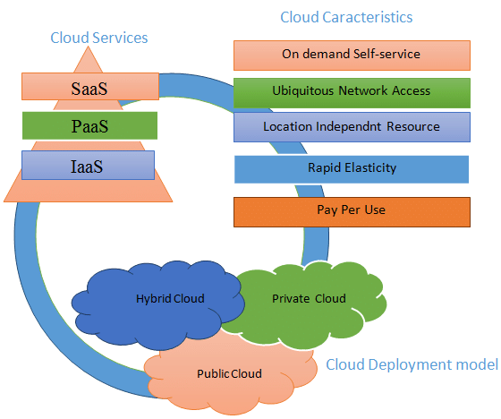

Figure-1: Cloud deployment models, Characteristics, and infrastructures. [2].

* **Cloud Computing deployment models:**

Cloud deployment models indicate how the cloud services are made available to users. Cloud Computing models define the type of the access to the cloud, how the cloud is located. The **four deployment models** associated with cloud computing are as follows [3]:

1. **Public Cloud:**

Public Cloud allows systems and services to be easily accessible to general public. Public cloud may be less secure because of its openness. The IT giants such as Google, Amazon and Microsoft offer cloud services via Internet.

1. **Private Cloud:**

Private Cloud allows systems and services to be accessible within an organization. The Private Cloud is operated only within a single organization. However, it may be managed internally by the organization itself or by third-party.

1. **Hybrid Cloud:**

Hybrid Cloud is a mixture of public and private cloud. Non-critical activities are performed using public cloud while the critical activities are performed using private cloud.

1. **Community Cloud:**

Community Cloud allows system and services to be accessible by group of organizations. It shares the infrastructure between several organizations from a specific community.

* **Cloud Computing service models:**

Service models are the reference models on which the Cloud Computing is based. There are many service models all of which can take from like XaaS, i.e. as Anything as a Service. This can be Network as a Service, Business as a Service and Database as a Service etc. But we categorize Cloud Computing into three basic service as listed below [3]:

1. **Infrastructure as a Service (IaaS):**

Infrastructure-as-a-Service provides access to fundamental resources such as physical machines, virtual machines, virtual storage, etc.

1. **Platform as a Service (PaaS):**

Platform-as-a-Service offers the runtime environment for applications. It also offers development and deployment tools required to develop applications. PaaS has a feature of point-and-click tools that enables non-developers to create web applications.

1. **Software as a Service (SaaS):**

Software-as–a-Service (SaaS) model allows to provide software application as a service to the end users. It refers to a software that is deployed on a host service and is accessible via Internet.

* **Essential Characteristics of Cloud Computing:**

The special publication includes the five essential characteristics of cloud computing [4]:

1. **On-demand self-service:** A consumer can unilaterally provision computing capabilities, such as server time and network storage, as needed automatically without requiring human interaction with each service provider.
2. **Broad network access:** Capabilities are available over the network and accessed through standard mechanisms that promote use by heterogeneous thin or thick client platforms (e.g., mobile phones, tablets, laptops and workstations).
3. **Resource pooling:** The provider's computing resources are pooled to serve multiple consumers using a multi-tenant model, with different physical and virtual resources dynamically assigned and reassigned according to consumer demand.
4. **Rapid elasticity:** Capabilities can be elastically provisioned and released, in some cases automatically, to scale rapidly outward and inward commensurate with demand.
5. **Measured service:** Cloud systems automatically control and optimize resource use by leveraging a metering capability at some level of abstraction appropriate to the type of service (e.g., storage, processing, bandwidth and active user accounts).

In this research I will use the **virtualization** technology to implement the Cloud Computing platform. Virtualization can be thought of as a way of abstracting computing and storage services away from implementation details and toward a more logical and less physical view of resources [4]. Virtualization is an inevitable technology that is highly coupled with the concept of cloud computing (Buyya et al., 2009; Ogigau-Neamtiu, 2012; Hashizume et al. 2013; Kim, 2009; Mosher, 2011; Atayero & Feyisetan, 2011; Zissis & Lekkas, 2012) – it is the virtualization technology that complements cloud services specially in the form of PaaS and SaaS where one physical infrastructure contains services or platforms to deliver a number of cloud users simultaneously.

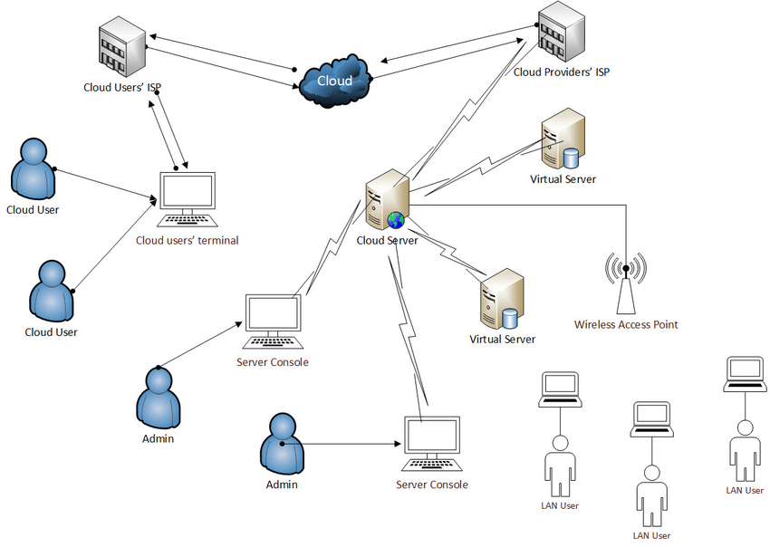

Figure-2: A Typical Cloud Architecture

Cloud services are popular because they can reduce the cost and complexity of owning and operating computers and networks. Some other benefits to users include scalability, reliability, and efficiency. Scalability means that cloud computing offers unlimited processing and storage capacity.

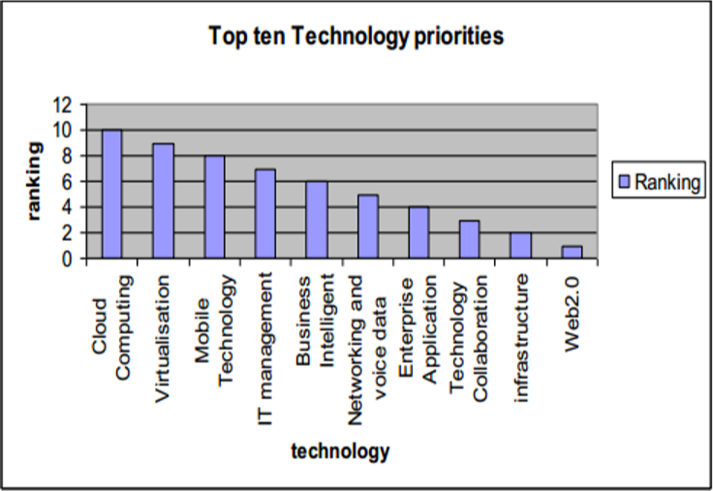

Figure-3: Priorities of Contemporary IT (Cervone, 2010)

Cloud computing was regarded as the top ten revolutionary technologies in IT industry.

REFERENCES:

# Peter Mell Timothy Grance “The NIST Definition of Cloud Computing” NIST Special Publication 800-145, September 2011.

# Omar ACHBAROU, My Ahmed EL KIRAM, Salim ELBOUANANI “A survey of Cloud Computing Attacks” December 2014.

# <https://www.tutorialspoint.com/cloud_computing/>

1. “The Definitive Guide to Cloud Computing” Book by Dan Sullivan and Don Jones

# Raja Mohamed Jabir, Salam Ismail Rasheed Khanji, Liza Abdallah Ahmad, Omar Alfandi “Analysis of cloud computing attacks and countermeasures” – 2016 [College of Technological Innovations, Zayed University, 144534, UAE]